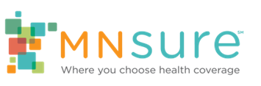

Account Maintenance
  - For use during August - September
With open enrollment approaching, it’s important that MNsure consumers keep their accounts updated. To help remind current MNsure users to update their accounts, we’ve created some social media posts highlight some common changes Minnesotans might have experienced throughout the year and how to report those changes to MNsure.

Suggested Post Copy
Life can change quickly. Make sure you report any changes to your income, household or address to @MNsure within 30 days to make sure you receive the right financial assistance & eligibility. Schedule your appointment with us today to make sure your account is up to date! [PHONE/WEBSITE]
Income changes may affect the coverage and/or savings you’re eligible for through @MNsure. If your income goes down, you may qualify for more savings than you’re getting now. Call us today at [PHONE] for help reporting any changes!
If your household size changes (marriage, birth, someone turning 26 and leaving your household, etc.), your health coverage and cost savings through @MNsure may change. We’re happy to help you with reporting that change. Give us a call at [PHONE]!
Updating your address ensures you get important information from @MNsure about your coverage and that you’re receiving the right amount of financial help. Need help? That’s what we’re here for! [PHONE/WEBSITE]
Be sure to keep your @MNsure account up to date! If you earn more than the income on your account or your household size decreases, you could owe money to the IRS next year. We can help you w/any changes [PHONE/WEBSITE]

Sample Social Media Graphics
