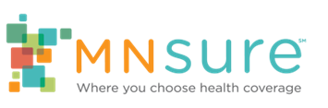

Social Media Toolkit
  - Resources to use during open enrollment, Nov. 1, 2023 – Jan. 15, 2024

Background
MNsure is Minnesota’s official health insurance marketplace. We connect Minnesotans who need health insurance with quality, comprehensive and exclusive access to discounts that lower health insurance costs.
MNsure’s open enrollment period runs November 1, 2023 – January 15, 2024. Open enrollment is the annual opportunity when Minnesotans across the state can compare health insurance options, sign up for coverage, or change plans through MNsure – without needing a qualifying life event.

Why Use Social Media
- Social media is an important tool for reaching Minnesotans. Ninety percent of Americans use social media; 74% of adults in the US use Facebook.
- When you regularly post interesting, relevant, or timely messages, you have more opportunities to grow your following and increase awareness of your organization or business.

Key Deadlines for Consumers
The deadline to enroll for health insurance that starts on January 1 is December 15, 2023.
If you enroll between December 16, 2023, and January 15, 2024, your health insurance will start February 1, 2024.
MNsure encourages Minnesotans to sign up ahead of the December 15 deadline so they can have the peace of mind that comes with a full year of health insurance coverage.

Savings Available in 2024
Federal legislation has enhanced advanced premium tax credits (APTC), meaning larger tax credits are available and more Minnesotans are eligible for these savings. These tax credits work like an instant discount to reduce the amount of monthly premiums for private health plans and are only available through MNsure.
MNsure estimates families who are eligible for APTC will save $6,750/year, on average, when they enroll in a 2024 health plan through MNsure. All Minnesotans can find a 2024 health plan with premiums that cost no more than 8.5% of their household income, also thanks to federal legislation.

Suggested Post Copy & Visuals
Included below are sample posts and graphics for your organization to use during open enrollment. High-resolution image files are available for download on Assister Central under Press and Social Media.

1. On November 1 (first day of MNsure’s open enrollment)
It’s time to get covered, Minnesota! @MNsure open enrollment for health insurance begins today. Sign up by December 15 to get the peace of mind that comes with a full year of coverage in 2024.

2. General messages for all assisters
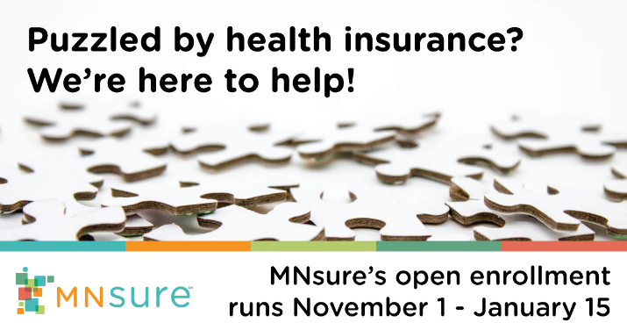
Puzzled by health insurance? We’re here to guide you through the whole @MNsure process, saving you time and energy. Schedule your free help session today [WEBSITE/PHONE]
Don’t miss out on savings! We can help you apply and enroll in quality, comprehensive health insurance for 2024 through @MNsure – and make sure you receive all the financial help you qualify for. Contact us today: [WEBSITE/PHONE]

3. Message specific to brokers
Need help deciding which health insurance plan is right for your family? That’s where we come in. We can give personalized, free advice & help you sign up through @MNsure. Contact us today: [WEBSITE/PHONE]
OR
We’re here to help you get the quality, comprehensive health insurance you deserve. We can help with your @MNsure application so you can be sure your family is covered when the unexpected happens. Contact us at [LINK/PHONE]

4. Message specific to navigators
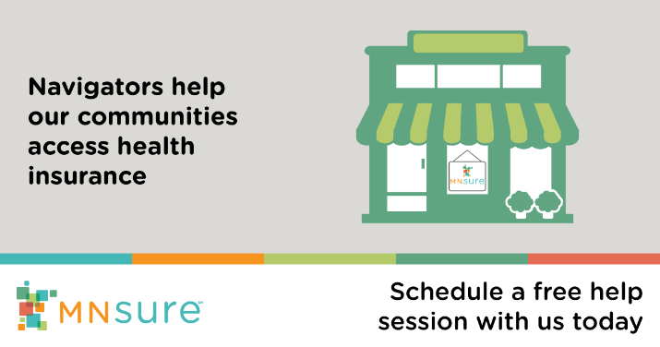
Every Minnesotan deserves quality, comprehensive health insurance. We’re here to help you sign up through @MNsure, the only place where you can get financial help to lower your costs. Meet with us today! [LINK/PHONE]
OR
We’re here to help you get the quality, comprehensive health insurance you deserve. We can help with your @MNsure application so you can be sure your family is covered when the unexpected happens. Contact us at [LINK/PHONE]

5. Leading up to Dec. 15 deadline (for coverage starting Jan. 1)
December 15 is the last day to sign up through @MNsure for health insurance that starts Jan. 1, 2024! Need help? Give us a call! [WEBSITE/PHONE]

6. December 16, 2023 – January 15, 2024 messages
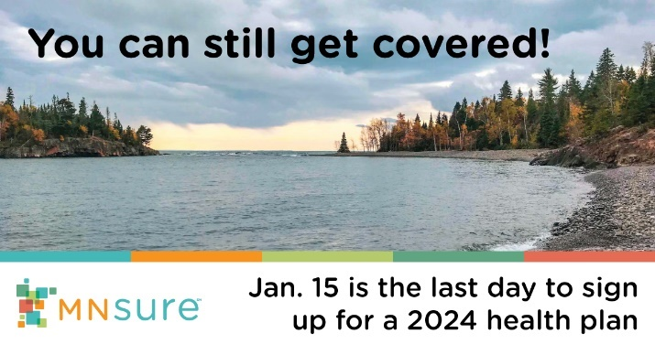
You can still get covered! We can help you sign up for quality, comprehensive health insurance and see if you qualify for savings. @MNsure open enrollment runs through Jan. 15, 2024. We’re here to help: [WEBSITE/PHONE]
Don’t delay getting quality, affordable health insurance for your family in 2024! The last day to sign up through @MNsure is January 15, for coverage that starts on February 1. We’re here to help: [WEBSITE/PHONE]

