Social Media Tool Kit for MNsure-Certified Navigators
Thank you for helping spread the word about the Minnesota Insulin Safety Net Program.
This toolkit includes posts that you can simply copy-and-paste and send from your own social media accounts.
Or if you prefer, use the provided imagery and create your own caption.

Contents
- Guide for posting on social media
- Social posts formatted for Twitter and Facebook.
- Corresponding images

Posting on Social Media

Twitter from a Desktop
Find the tweet text box at the top of your feed.

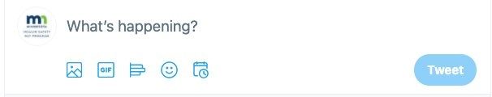
Click in the text box. Copy-and-paste one of the provided posts or write your own. Add the matching photo using the picture icon. Select the photo from your computer.
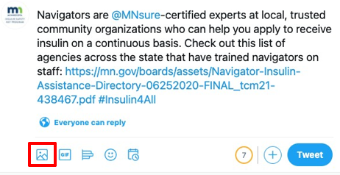
Click the blue “Tweet” icon to publish the tweet. If you want to schedule the tweet to send later, select the calendar icon.
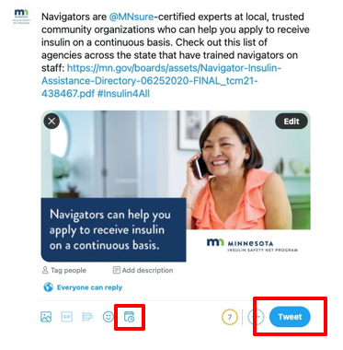
Choose the time and date for your tweet to send and confirm.
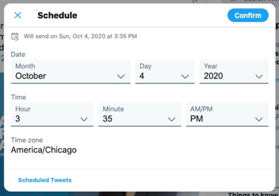

Twitter from a Mobile Device:
Open the Twitter application. Click the blue “new tweet” icon in the bottom right.
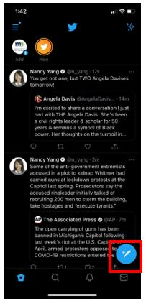
Copy-and-paste the provided tweets or write your own.
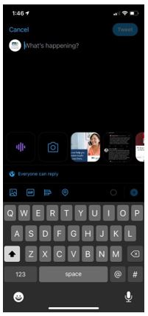
Post as is or add a photo.
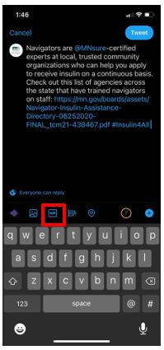
Add photo from your phone library. Click the blue “Tweet” icon to publish the tweet.
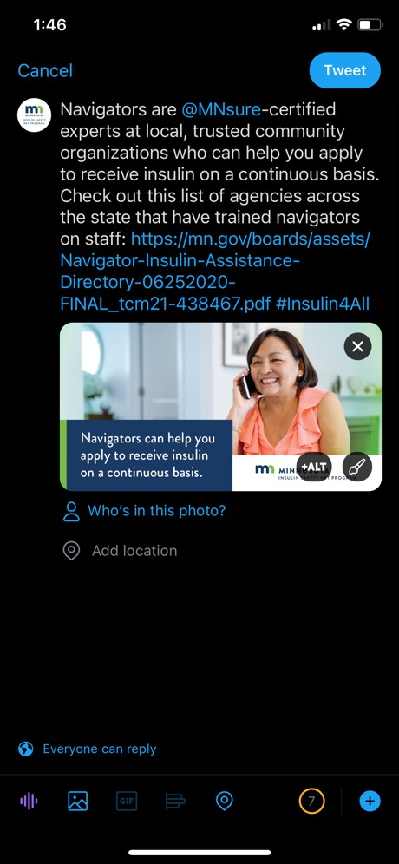

Facebook from a Desktop
Click the text box at the top of your Facebook home feed.
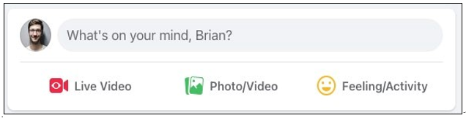
Copy-and-paste a provided post or write your own.
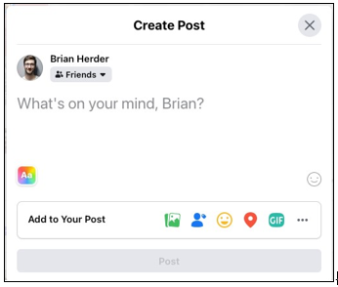
Post as is, or to add a photo, click the X in the right-hand corner of the link box.
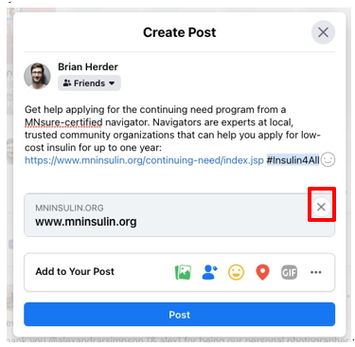
Choose the photo icon.
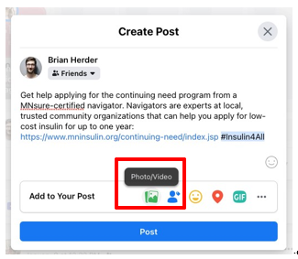
Upload photo from your phone and click “Post”.
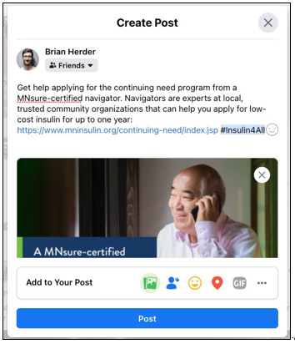

Facebook on a Mobile Device
Click the post button at the top of your home feed.
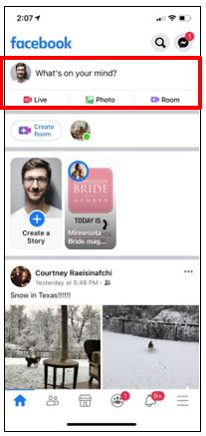
Copy-and-paste one of the provided posts or write your own. Post or add a photo by clicking the “photo” icon.
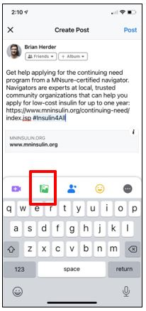
Upload your photo from your device and post.
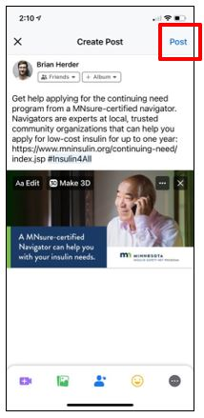

Social Posts for Twitter and Facebook

Post #1
Minnesota is proud to be the first state to provide affordable insulin through a safety net program. Whether your need is urgent or continuing, you can visit our website to learn how to apply: https://www.mninsulin.org/ #Insulin4All
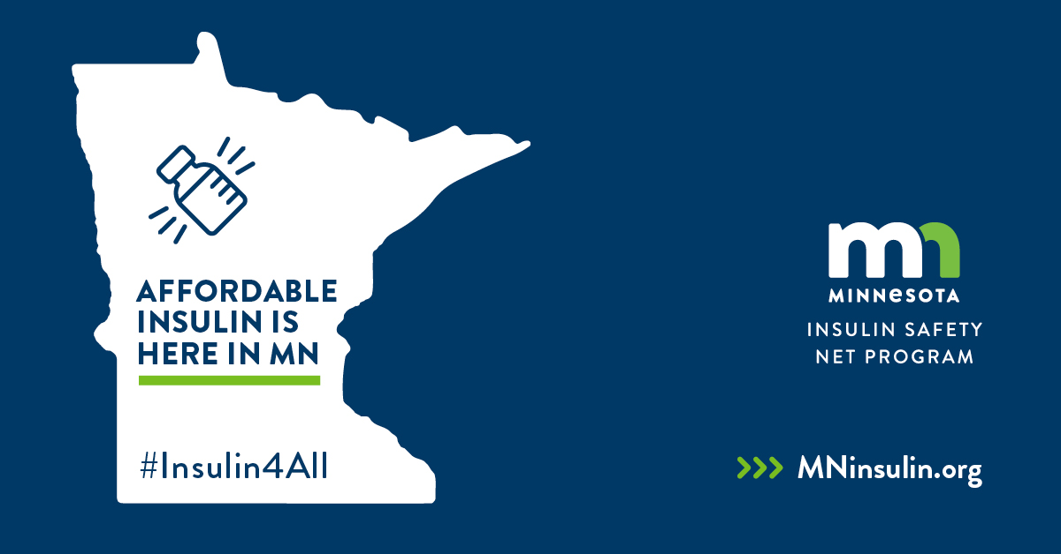

Post #2
Navigators are @MNsure-certified experts at local, trusted community organizations who can help you apply to receive insulin on a continuous basis. Check out this list of agencies across the state that have trained navigators on staff: https://bit.ly/39J22Ol #Insulin4All
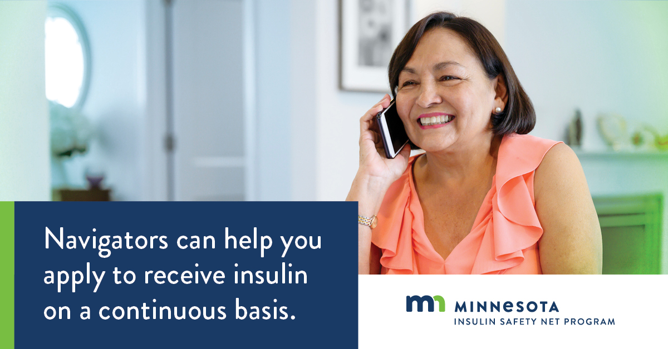

Post #3
Have you ever had to ration your insulin to extend your supply because you couldn’t afford it? This should not be anyone’s reality. If you have an urgent need for insulin, there is help available: https://www.mninsulin.org/ #Insulin4All
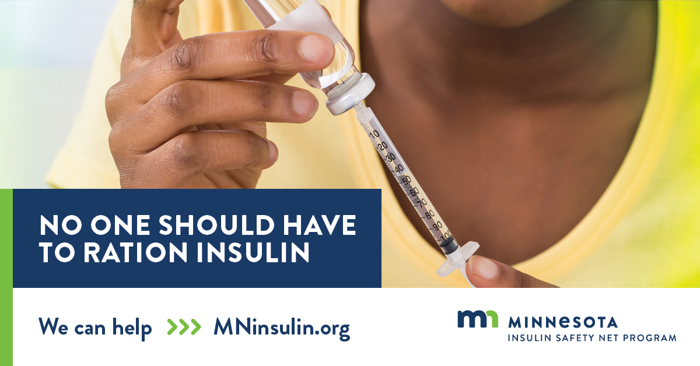

Post #4
The continuing need portion of the Minnesota Insulin Safety Net Program can provide insulin to eligible individuals for up to one year with a co-pay of no more than $50 for each 90-day supply. See if you qualify for the continuing need program: http://bit.ly/2FZdVoS #Insulin4All 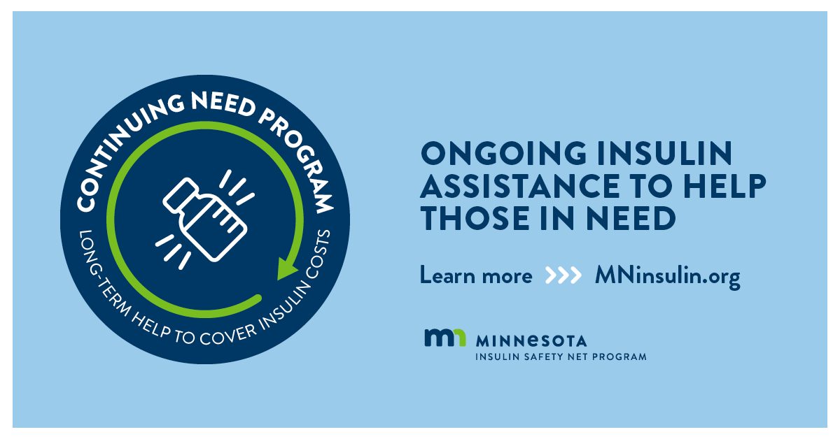

Post #5
Get help applying for the continuing need program from a MNsure-certified navigator. Navigators are experts at local, trusted community organizations that can help you apply for low-cost insulin for up to one year: http://bit.ly/2FZdVoS #Insulin4All
