Social Media Toolkit
  - For 12/20 Deadline

Graphics & Sample Posts

Facebook
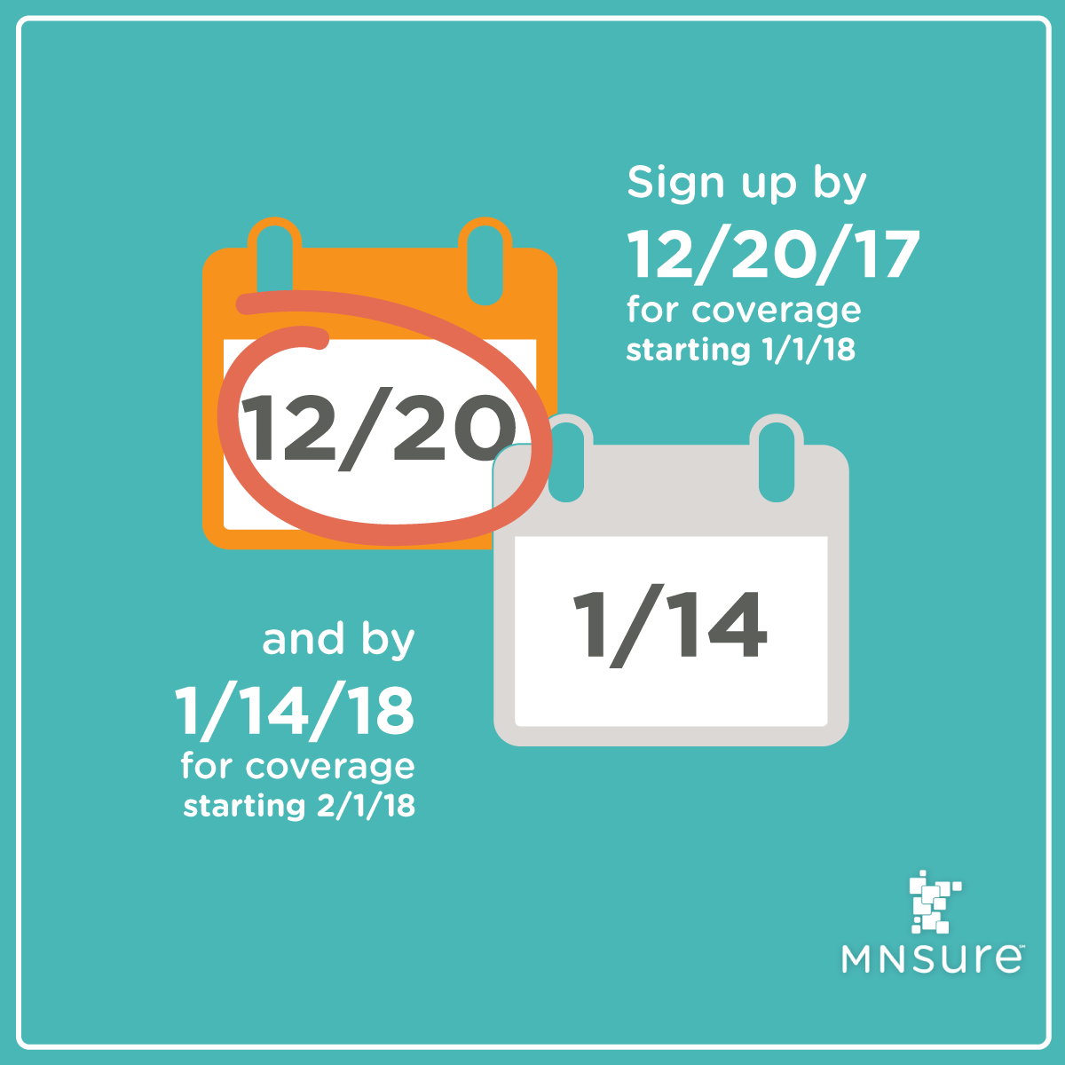
Make sure you’re planning ahead. The deadline to #getcovered starting January 1 is coming up soon. Apply by Dec. 20 to avoid a gap in coverage. You can still apply between December 20 and January 14 for coverage starting February 1, 2018.

Now is the time to apply! The deadline for Minnesotans to #getcovered by January 1 is December 20. Find an event near you for free help to make sure you get your application in: bit.ly/MNsureEvents
If you don’t want a gap in your health insurance coverage, be sure to apply in the next five days. Shop at MNsure.org to compare plans, see if you’re eligible for financial help, and avoid a tax penalty. Here are some tips to get you started: bit.ly/MNsureTipSheet
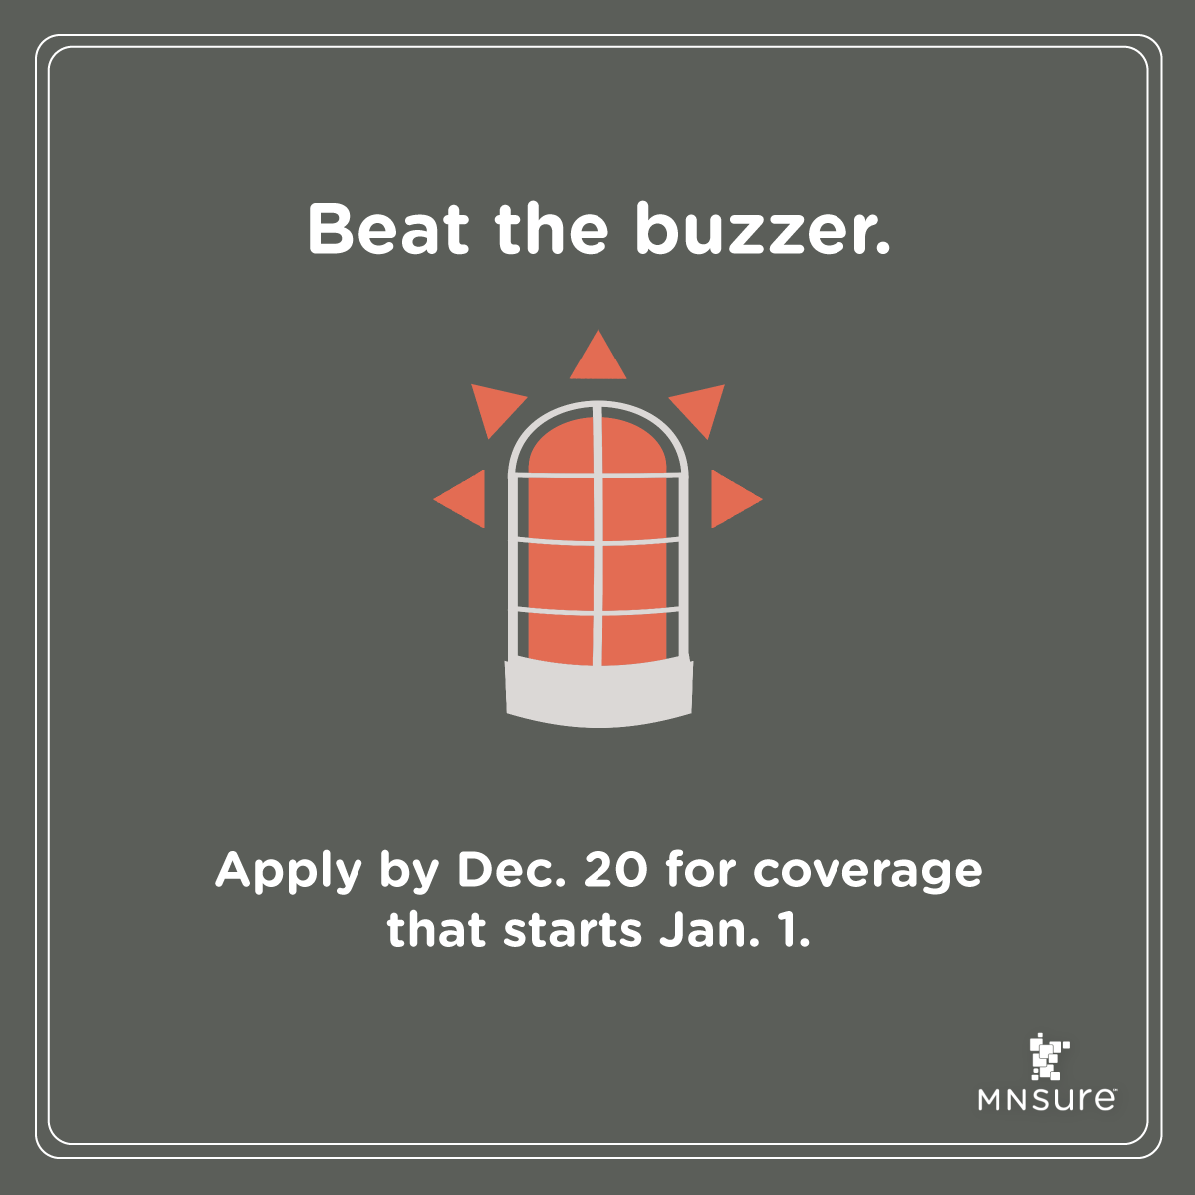
Health insurance isn’t something you want to leave until the last minute. It’s the last weekend before the deadline for #Minnesotans to get coverage that starts on January 1, so apply today on MNsure.org!
Now is not the time to wait for it. The deadline to get insurance that starts January 1 is December 20. Head on over to MNsure.org to compare plans, apply, and enroll now.
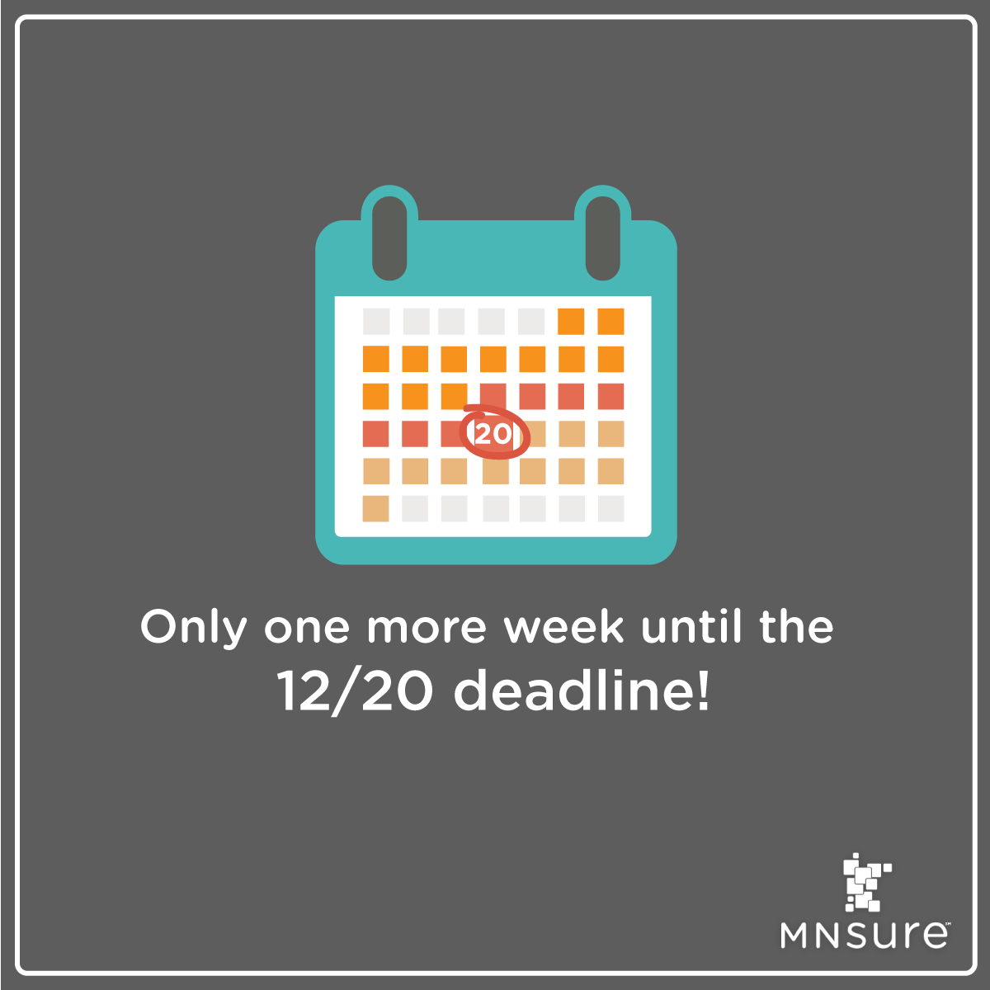
Here in Minnesota, open enrollment goes until January 14. But that doesn’t mean you should wait. Apply by December 20 (next Wednesday) to start off the new year with health insurance. Visit MNsure.org
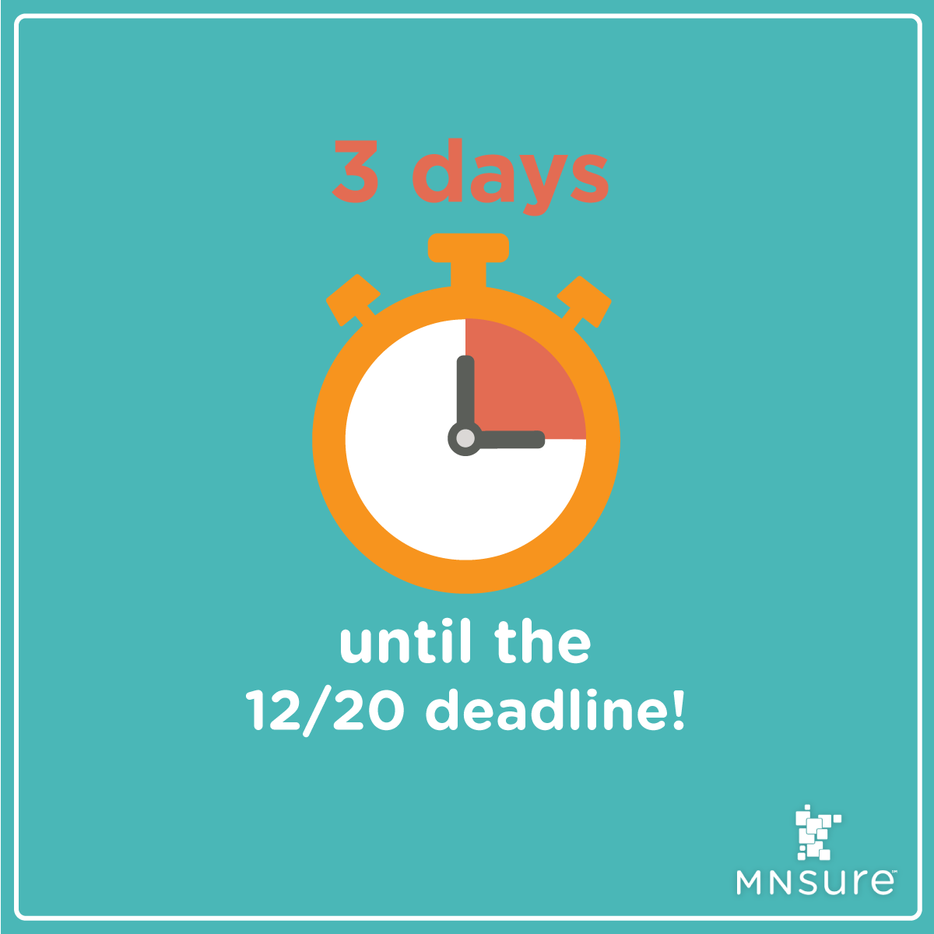
Have you applied yet? Don’t delay. Only three more days to get coverage that starts January 1!
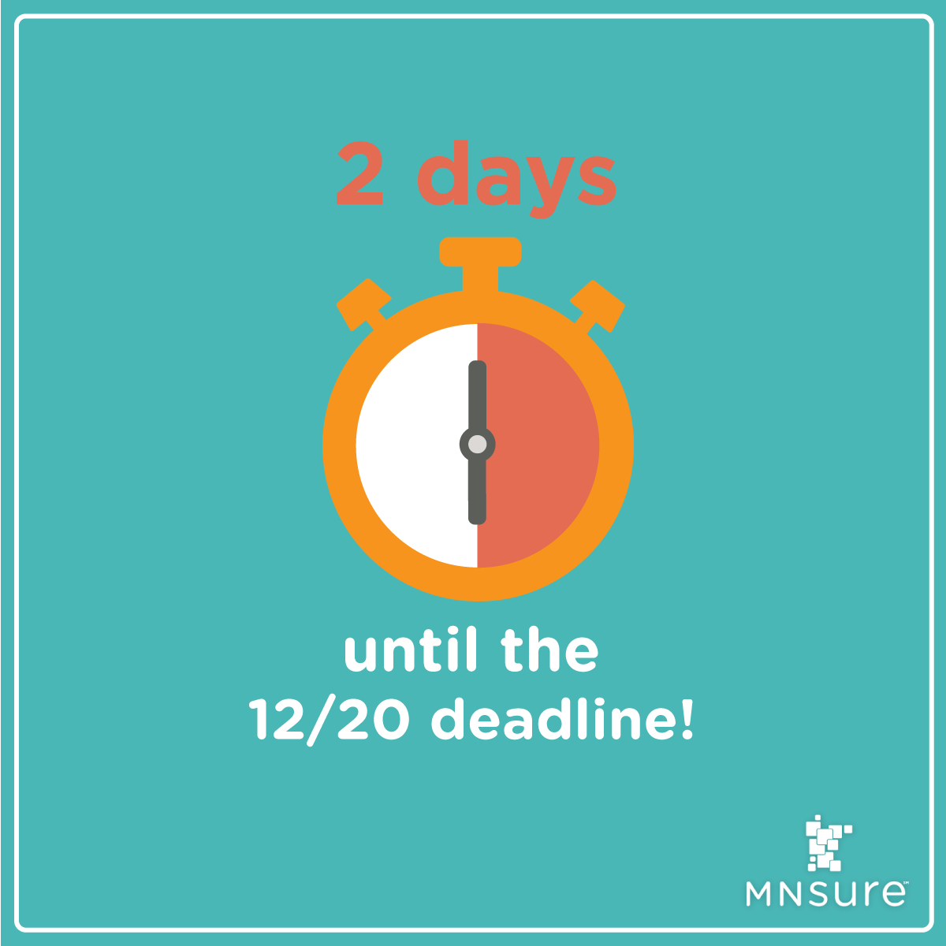
Time is running out to get coverage that starts January 1. The deadline is getting close, but there are still plenty of enrollment events where you can get FREE help applying & enrolling. Find one near you: bit.ly/MNsureEvents
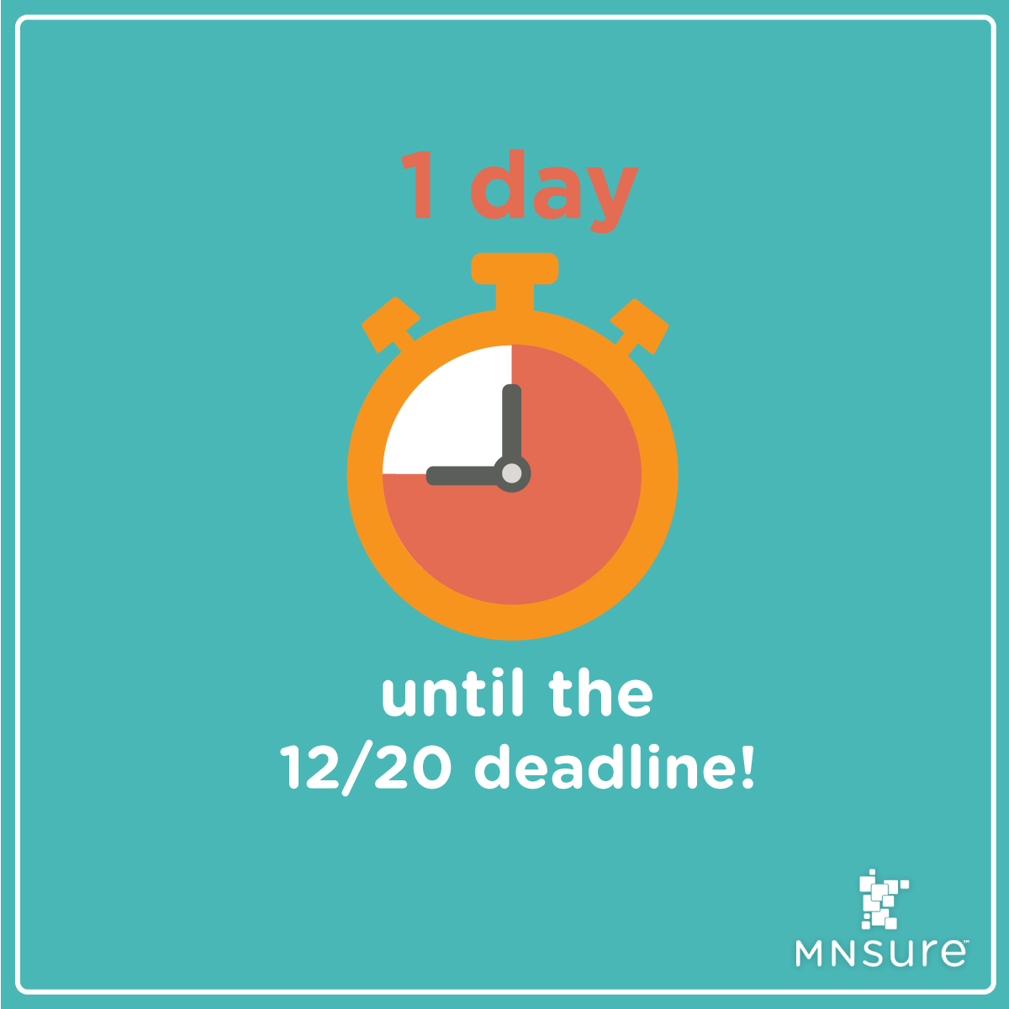
Tomorrow’s the big day, so make sure you’re prepared. Visit bit.ly/PlanComparison2018 to make sure you’re getting the best plan to fit your needs. And then apply so you can #getcovered on January 1.
There’s still time to #GetCovered for January 1! The #MNsure Contact Center lines are open and ready to help!
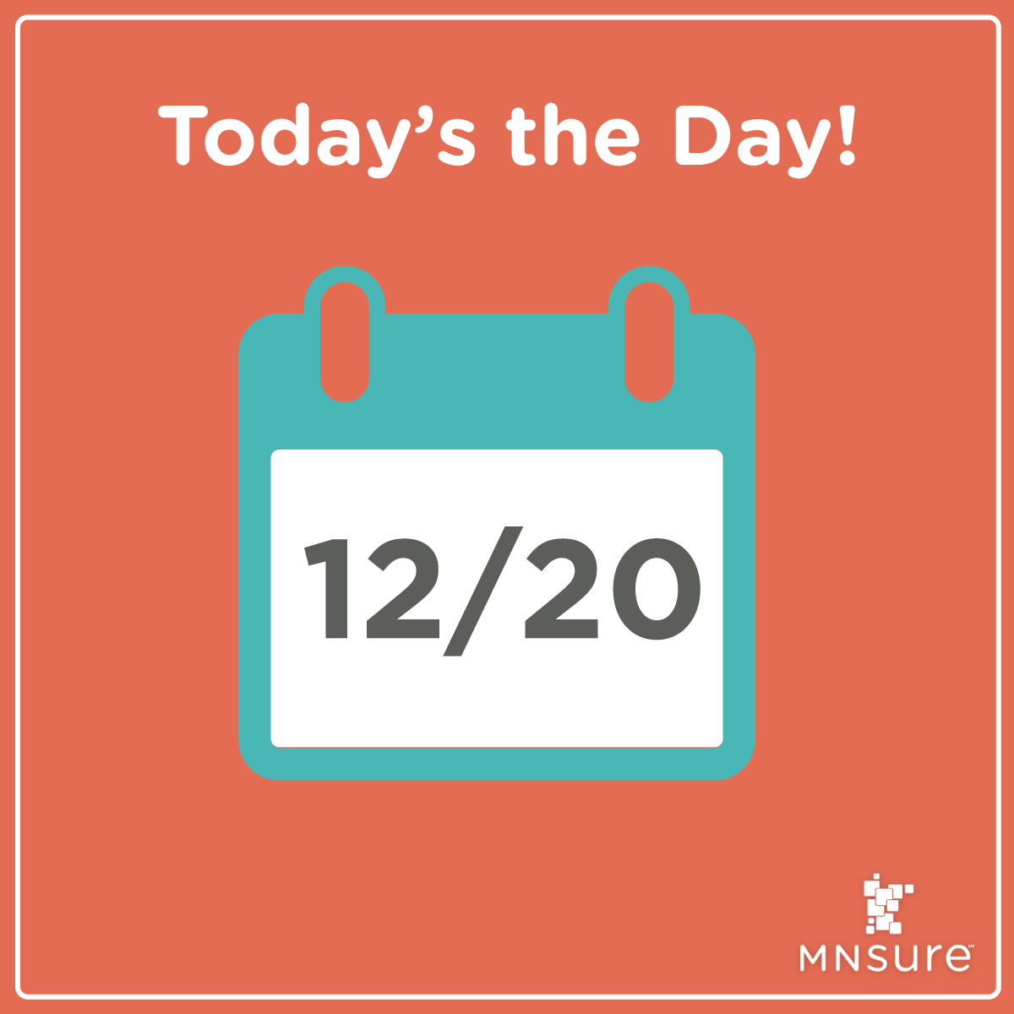
Today’s the last day you can get health insurance that starts January 1! Make sure you get enrolled and avoid a gap in your coverage.
Your dogs are counting on you. Make sure you #GetCovered so you can be there for them. Enroll by December 20 to get insurance that starts January 1.
Enroll by December 20 so you can get health insurance that starts January. Then you can get back to snuggling your feline friends.

Twitter
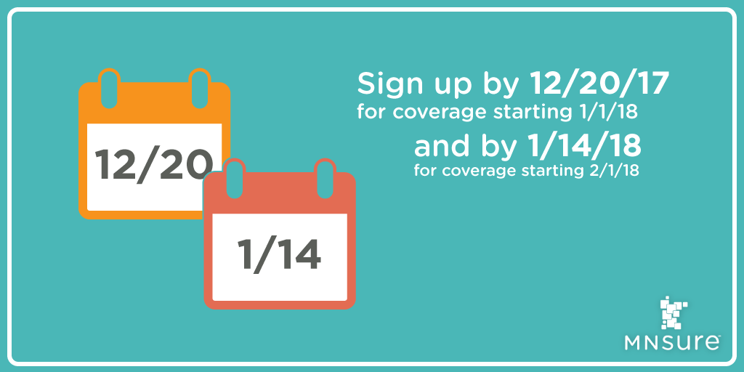Make sure you plan ahead! Apply by Dec. 20 to start coverage on Jan. 1. Or by Jan. 14 to start Feb. 1.

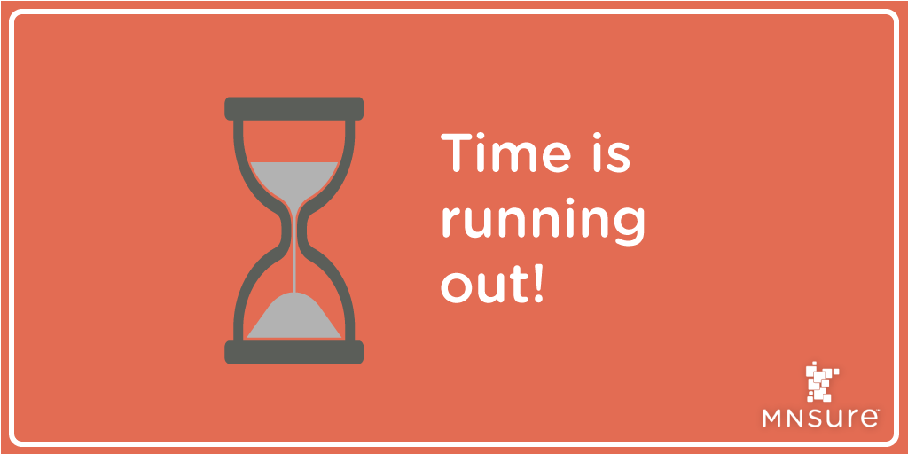
Don’t put off your health coverage any longer! The deadline for coverage starting 1/1/18 is 12/20/17. Apply today at MNsure.org
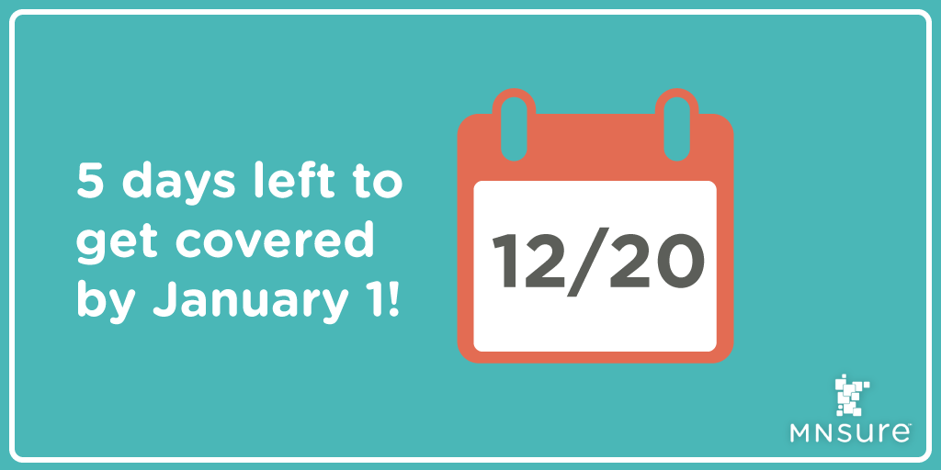
Avoid a gap in coverage! Shop at MNsure.org to compare plans side by side, determine if you're eligible for financial help, and avoid the tax penalty. Start here: bit.ly/ComparisonTool

You don’t want to wait until the last second to get health insurance. It’s the last weekend before the deadline to #GetCovered on 1/1. Apply today on MNsure.org
If you’re not willing to wait for health insurance, now is the time to seize the day. Apply by 12/20 for coverage that starts 1/1.

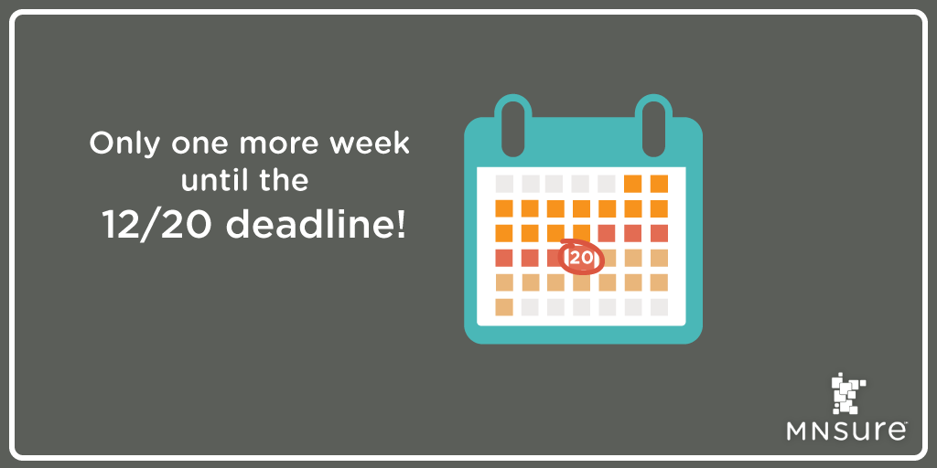
Here in Minnesota, open enrollment goes until 1/14. But that doesn’t mean you should wait. Apply by 12/20 (next Wed.) to start off the new year with health insurance. Visit MNsure.org

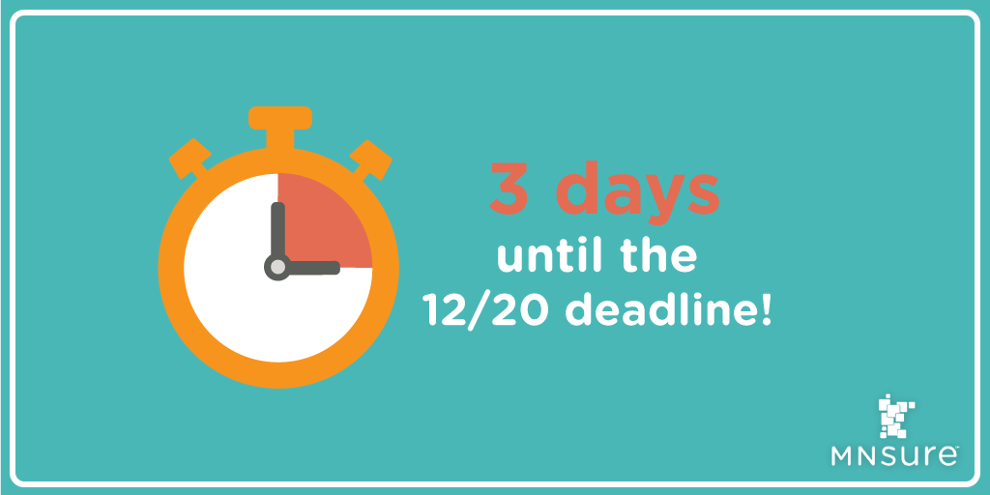
The deadline is getting close, but there are still plenty of enrollment events where you can get FREE help. Find one near you: bit.ly/MNsureEvents

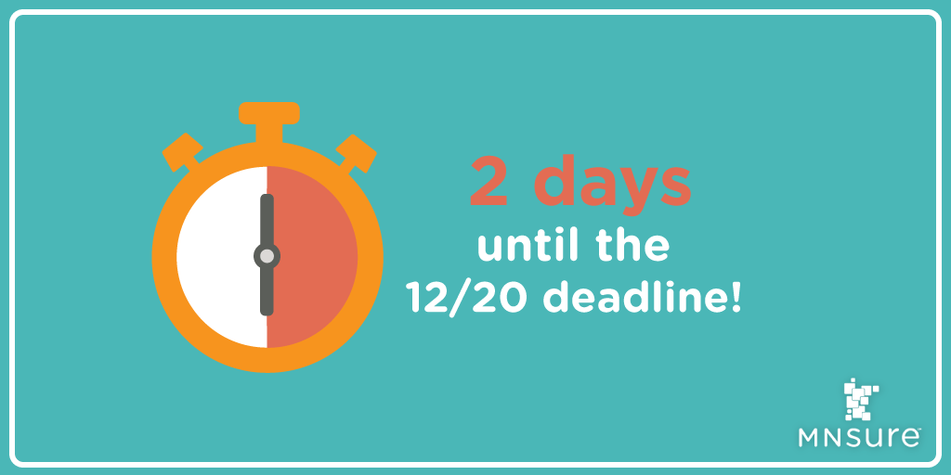
The deadline for 1/1 coverage is coming up fast, so make sure you’re prepared. Visit bit.ly/PlanComparison2018 to make sure you get the best plan for you.
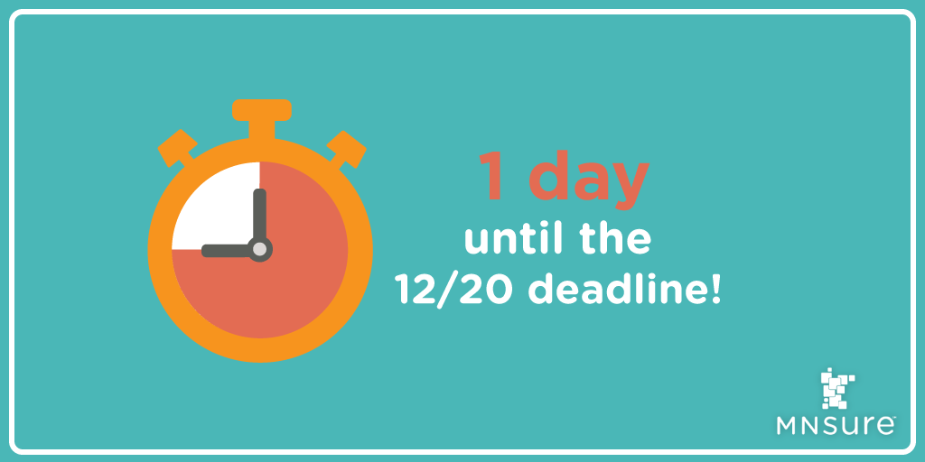
One day more to apply for health insurance that starts Jan. 1. Have you applied yet? Visit MNsure.org

There’s still time to #GetCovered for January 1! The #MNsure Contact Center lines are open and ready to help!

Today’s the last day you can get health insurance that starts January 1! Make sure you get enrolled today and avoid a gap in coverage.

Your dogs are counting on you. Make sure you #GetCovered so you can be there for them. Enroll by 12/20 to get insurance that starts 1/1.

Enroll by 12/20 for insurance that starts 1/1! Get free application & enrollment help from an assister, so you can focus on snuggling your cat: bit.ly/FindAnAssister

Useful Links
MNsure Facebook: https://www.facebook.com/MNsure/
MNsure Twitter: https://twitter.com/MNsure
Find an Assister Home Page: bit.ly/FindAnAssister
Broker Enrollment Centers: bit.ly/FindABroker
Enrollment Events: bit.ly/MNsureEvents
Plan Comparison: bit.ly/PlanComparison2018
Online Help Form: bit.ly/MNsureHelpForm
Who to Contact When: bit.ly/MNsureCustService
Part of All of Us video: https://youtu.be/oEIUF78LLqs

