American Rescue Plan
  - For use during COVID-19 Special Enrollment Period, extended to July 16, 2021, and American Rescue Plan (ARP)
Recent changes to the Affordable Care Act (ACA) made through the American Rescue Plan mean more Minnesotans will be able to access tax credits through MNsure and most current enrollees will receive increased tax credits for 2021 and 2022. To give Minnesotans to take advantage of these expanded financial benefits, MNsure has extended the COVID-19 Special Enrollment Period to July 16, 2021.

Suggested Post Copy

ARP
Starting this spring, Minnesotans will see increased tax credits through @MNsure. Learn more about the new benefits & how to enroll: http://bit.ly/MNsureARP
Good news for Minnesotans! Thanks to recent federal changes, more Minnesotans will be able to get more financial help, available only through @MNsure. Learn more at http://bit.ly/MNsureARP
Think your income is too high to get help paying for insurance through @MNsure? Think again! Recent changes to the ACA mean Minnesotans with higher incomes may qualify. http://bit.ly/MNsureARP
Thanks to the American Rescue Plan, many Minnesotans will now receive bigger tax credits to lower their health coverage costs, only available through @MNsure.org. More info: http://bit.ly/MNsureARP

Extended Deadline
Thanks to changes to the ACA, more Minnesotans will be able to access more financial help through @MNsure. And to help Minnesotans take advantage of these increased benefits, MNsure has extended the COVID-19 Special Enrollment Period through July 16, 2021!

Still need health coverage? @MNsure is giving you more time to take advantage of increased financial help, thanks to the federal coronavirus relief. Minnesotans can enroll through July 16! Learn more & enroll at MNsure.org

If you've recently lost your coverage or didn't enroll during open enrollment this past fall, you have another chance! @MNsure.org's special enrollment period has been extended to July 16

If you've recently lost your coverage or didn't enroll during open enrollment this past fall, you have another chance! @MNsure.org's special enrollment period has been extended to July 16

Social Graphics
We encourage you to use the graphics highlighted below alongside the above copy. The high-resolution graphics are included in the attached folder.

ARP
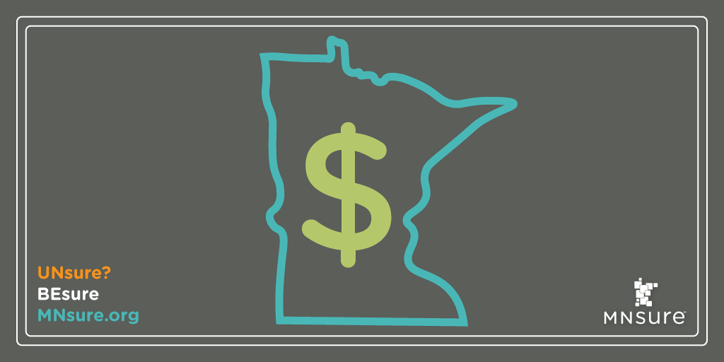

Extended Deadline
